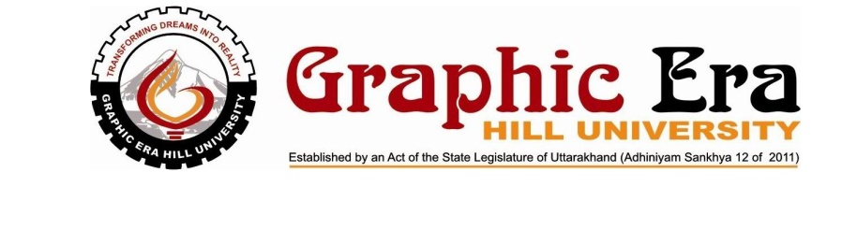

MOOC FILE
BCA FORTH SEMESTER
SESSION 2019-20

Submitted to: Submitted by:
Devendra Rautela Deepak Kumar
Assistant Professor BCA
Computer Science & Engineering 2071360
Graphic Era Hill University
Bhimtal Campus

COLLEGE ROLL NO : 09 EXAMINATION ROLL NO : 2071360

THIS IS TO CERTIFY THAT MR. DEEPAK KUMAR HASSATISFACTORILY COMPLETED ALL THE EXPERIMENTS IN THE LABORATORY OF THIS
COLLEGE. THE COURSE OF THE MOOC FILE ON INTERNET OF THINGS IN PARTIAL FULLMENT OF THE REQUIREMENT IN 4TH SEMESTER OF BCA DEGREE COURSE PRESCRIBED BY THE GRAPHIC ERA HILL UNIVERSITY BHIMTAL DURING THE YEAR 2019-20 .

CONCERNED FACULTY: HEAD OF DEPARTMENT:

NAME OF EXAMINER:

SIGNATURE OF EXAMINER:

